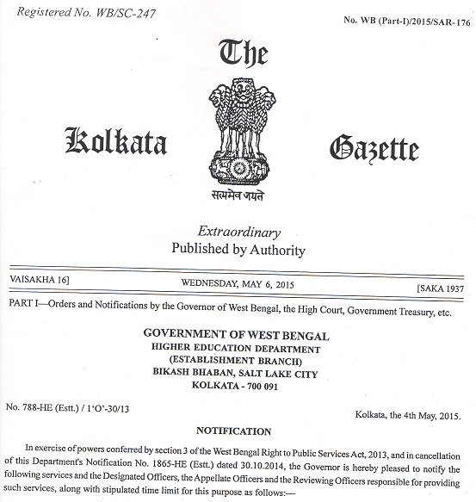

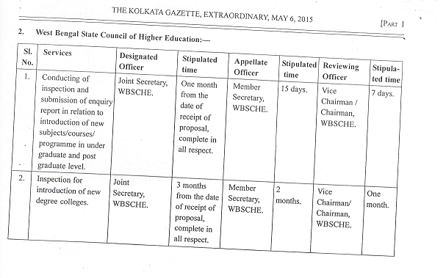

Complete in all respect means

* Must be applied through the prescribed form(s)for UG, PG and New General Degree College.
* Forms are available in the website of the Council.
* Necessary supporting documents along with “Application Fees”, as mentioned in the form(s), are to be submitted along with the application(s) in due time.
* Besides, any other documents as may be required by the Council during the process of the application are to be submitted.